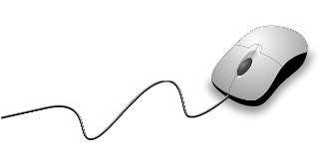[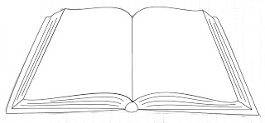](http://www.google.com/url?sa=i&rct=j&q=&esrc=s&source=images&cd=&ved=0ahUKEwicgbni3ebOAhURBh4KHU-7DuAQjRwIBw&url=http://weeklydoodles.blogspot.com/2010/02/making-of-open-book-with-illustrator.html&bvm=bv.131286987,d.dmo&psig=AFQjCNEpLMkDGZRNo8re2xLuzWMeVCiScg&ust=1472563739668953)Welcome to **Fifth Grade**

**LIBRARY**

**Shippensburg Area**

**Intermediate School**

**{2023-2024 Class Syllabus}**

[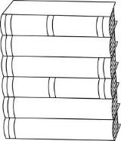](https://www.google.com/url?sa=i&rct=j&q=&esrc=s&source=images&cd=&cad=rja&uact=8&ved=0ahUKEwjGn82n4-bOAhVEpx4KHb2HBQAQjRwIBw&url=https://www.pinterest.com/lanajon/keep-austin/&bvm=bv.131286987,d.dmo&psig=AFQjCNEEhQ1rrByKwwFXPCd8mIZSd3peoQ&ust=1472565268879538)****

**Grading**

Students are graded on a scale of O (outstanding), S (satisfactory), N (needs improvement) Grades are recorded in Skyward.

**About Mrs. Jones**

Mrs. Beth Jones has been teaching library classes for 15 years. She has earned her B.S.Ed. in Social Studies (Shippensburg University), M.S.L.S. in School Library Media (Clarion University), and M.S. Ed. in Educational Development and Strategies (Wilkes University). She enjoys reading, travel, horses, and spending time with her family. She lives in Newburg.

**In this course you will …**

Students willlearn skills, including how to find, use, and evaluate information using books, databases, and websites. We will also review library organization, focus on some graphic novels, complete a research project, practice speaking skills, and learn about some popular authors. It will be a fun year of learning!

**Expectations**

Students are expected to follow the schoolwide PBIS program goals:

**Be Respectful**

**Be Responsible**

**Be Safe**

**Destiny Quest & Library Website**

Library catalog:

[**https://shipk12.follettdestiny.com**](https://shipk12.follettdestiny.com)

**SAIS Library website:** <http://sasdlibrarydepartment.weebly.com/intermediate-school-4-5.html>

**Class Schedule**

Library lessons consist of a 25 minute lesson in library skills, as well as a 20 minute checkout/ centers/ makerspace time weekly. Students may also exchange books any morning between 8:40-9:00 with their teacher’s permission.

**Class Assignments**

Students will complete a variety of assessments, including in-class assignments, skills checks, short quizzes, individual projects, and group projects. All work will be completed during the student’s library class time; there will be no homework.

**Book Checkout**

Students may check out two library books at a time from the library’s 12,000 volume collection. If something from the library gets damaged, it is the student's responsibility to tell the librarian so that she can attempt to repair it, often without cost to the student. However, if a library book or audiobook is damaged so that it cannot be used, a replacement or repair fee may be charged. If a book is lost, the student is responsible for a replacement fee (or providing a copy of the book). If the lost item is found and returned in good condition prior to the end of the school year, then the replacement fee is refunded.

Fifth grade library media class is a year-long course. Students come to the library once each six day cycle. They will also have a technology/ keyboarding class for part of the year.

**Mrs. Beth Jones • Room 173 •** [**beth.jones@ship.k12.pa.us**](mailto:beth.jones@ship.k12.pa.us) **• 717-530-3189**