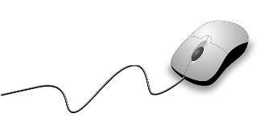[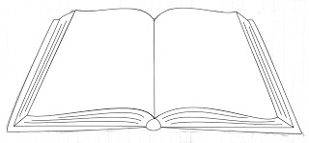](http://www.google.com/url?sa=i&rct=j&q=&esrc=s&source=images&cd=&ved=0ahUKEwicgbni3ebOAhURBh4KHU-7DuAQjRwIBw&url=http://weeklydoodles.blogspot.com/2010/02/making-of-open-book-with-illustrator.html&bvm=bv.131286987,d.dmo&psig=AFQjCNEpLMkDGZRNo8re2xLuzWMeVCiScg&ust=1472563739668953)Welcome to **Fourth Grade**

**LIBRARY**

**Shippensburg Area**

**Intermediate School**

**{2018 – 2019 Class Syllabus}**

[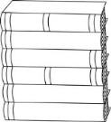](https://www.google.com/url?sa=i&rct=j&q=&esrc=s&source=images&cd=&cad=rja&uact=8&ved=0ahUKEwjGn82n4-bOAhVEpx4KHb2HBQAQjRwIBw&url=https://www.pinterest.com/lanajon/keep-austin/&bvm=bv.131286987,d.dmo&psig=AFQjCNEEhQ1rrByKwwFXPCd8mIZSd3peoQ&ust=1472565268879538)****

**Grading**

Students are graded on a scale of O (outstanding), S (satisfactory), N (needs improvement), to include +/-.

**Expectations**

Students are expected to follow the schoolwide PBIS program goals:

**Be Respectful**

**Be Responsible**

**Be Safe**

**Destiny Quest & Library Website**

**Library catalog:**

[**https://shipk12.follettdestiny.com**](https://shipk12.follettdestiny.com)

**SAIS Library website:** <http://sasdlibrarydepartment.weebly.com/intermediate-school-4-5.html>

**Class Schedule**

Library lessons consist of a 20 minute lesson in library skills, as well as a 20 minute checkout and centers time weekly. Students may also come to the library between 8:40-9:00 any morning with their classroom teacher’s permission.

**About Mrs. Jones**

Mrs. Beth Jones has been teaching library classes for 11 years. She has her B.S.Ed. in Social Studies, M.S.L.S. in School Library Media, and M.S. Ed. in Educational Development and Strategies. She enjoys reading, travel, horses, and spending time with her family, which includes her husband, John, and three young children.

**Class Assignments**

Students will complete a variety of assessments, including in-class assignments, skills checks, short quizzes, individual projects, and group projects. All work will be completed during the student’s library class; there will be no homework.

**Book Checkout**

Students may check out two library books at a time from the library’s 12,000 volume collection. If something from the library gets damaged, it is the student's responsibility to tell the librarian so that she can attempt to repair it, often without cost to the student. If a book is lost, the student is responsible for a replacement fee. If the lost item is found and returned in good condition prior to the end of the school year, then the replacement fee is refunded. Also, if a library book or audiobook is damaged so that it cannot be used, a replacement or repair fee may be charged.

**In this course you will …**

Students willlearn skills, including how to find, use, and evaluate information using books, eBooks, databases, and websites. We will discuss library organization, popular authors, genres, speaking skills, and information literacy, as well as online safety. It will be a fun year of learning!

Fourth grade library media class is a year-long course. Students come to the library once each six day cycle. They will also come to the computer lab for technology and keyboarding lessons for half of the year.

**Mrs. Beth Jones • Room 173 •** [**beth.jones@ship.k12.pa.us**](mailto:beth.jones@ship.k12.pa.us) **• 717-530-3189**